

**School of Engineering and Applied Science,**

**Ahmedabad University**

**CSE300 Software Engineering**

**Weekly Report**

**Guided By: Prof Khushru Doctor**

**TA Muskan Matwani**

**TA Anupama Nair**

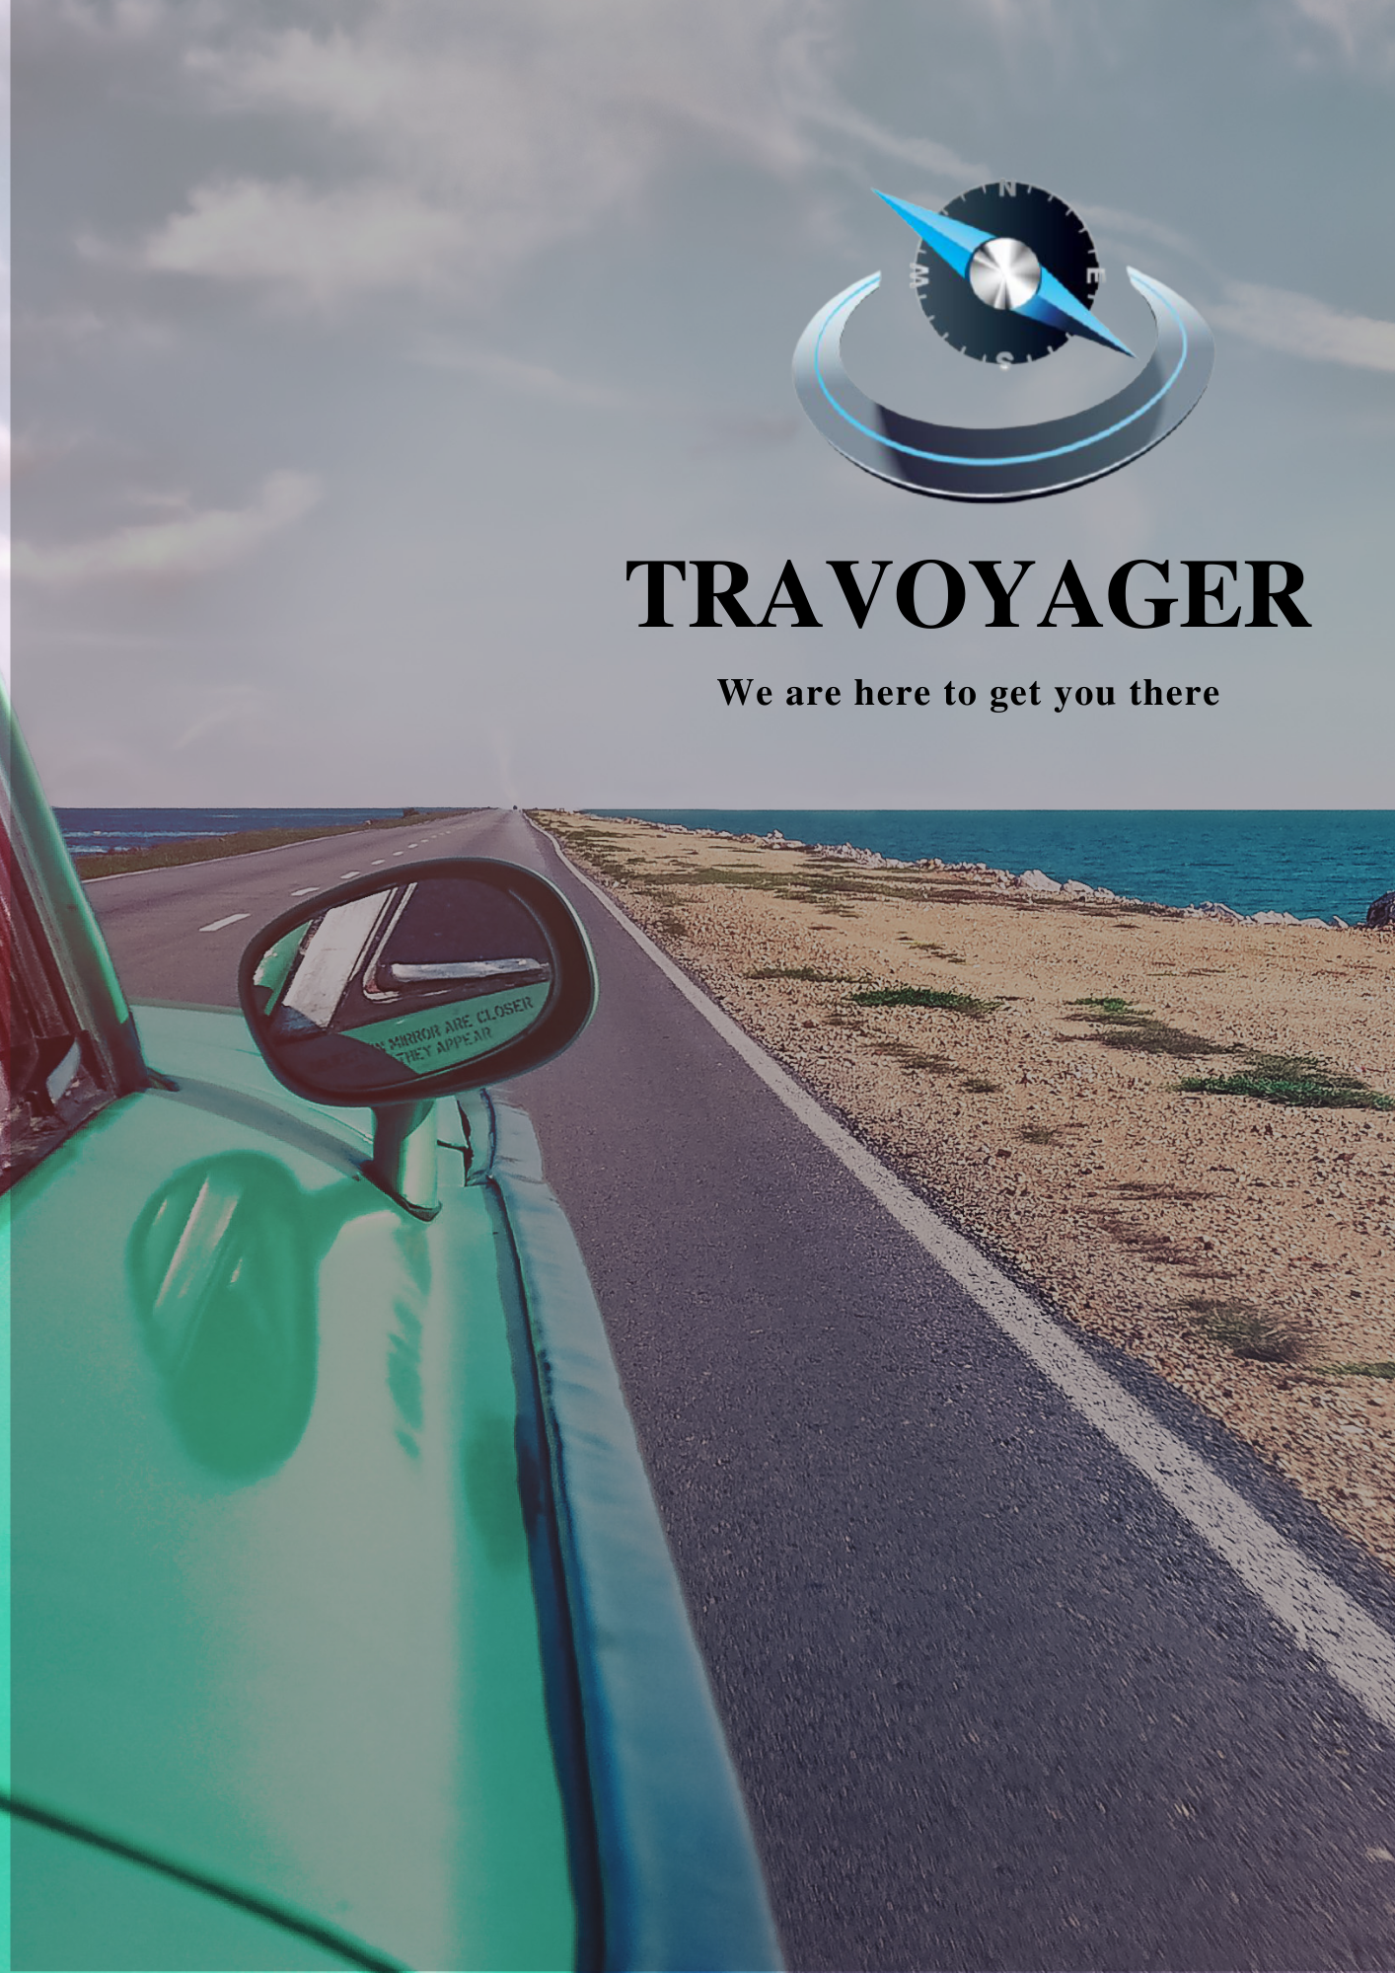

**WEEKLY MEETING REPORT - 6**

**Agenda** - Sprint 1 Discussion

**Date and Time**

**________________________________________________________________________________________________________________________________________________________________________________________________________________________________________________________________________________________________________________________________________________________________________________________________________________________________**

March 14, 2021 11:00 A.M.-12:00 P.M.

**Location**

**________________________________________________________________________________________________________________________________________________________________________________________________________________________________________________________________________________________________________________________________________________________________________________________________________________________________**

Google Meet

**Schedule**

**________________________________________________________________________________________________________________________________________________________________________________________________________________________________________________________________________________________________________________________________________________________________________________________________________________________________**

|  |  |
| --- | --- |
| **Time** | **Description** |
| 11:00-11:05 A.M. | Attendance |
| 11:05-11:30 A.M. | Progress Sharing |
| 11:30-11:45 A.M. | Backlog Discussion |
| 11:45-11:55 A.M. | Sprint 2 |
| 11:55 A.M. - 12:00 P.M. | Summary |
| 12:00 P.M. | Meeting Adjourned |

**Details**

**________________________________________________________________________________________________________________________________________________________________________________________________________________________________________________________________________________________________________________________________________________________________________________________________________________________________**

As per discussion within the team and the requirement of the project, the sprints decided are as follows:

1. Process
   1. Frontend Team
      1. Shared the screen design
      2. Discussed the flow of the screens of the website
   2. Backend Team
      1. Completion of ER Diagram
      2. Initialization of database design
2. Backlog
   1. Frontend Team
      1. NULL
   2. Backend Team
      1. Some tables left to be prepared

**Conclusion**

**________________________________________________________________________________________________________________________________________________________________________________________________________________________________________________________________________________________________________________________________________________________________________________________________________________________________**

As per the sprints decided, frontend and backend teams were assigned the tasks accordingly for Sprint 2. Beginning of Sprint 2.

**Next Meeting Details**

**________________________________________________________________________________________________________________________________________________________________________________________________________________________________________________________________________________________________________________________________________________________________________________________________________________________________**

March 21,2021 11:00A.M. -12:00P.M.

**Next Agenda**

**________________________________________________________________________________________________________________________________________________________________________________________________________________________________________________________________________________________________________________________________________________________________________________________________________________________________**

Sprint 2 Discussion